FACULTY EVALUATION
Programme Name: SEP Scale Masterclass Module 2 Tanzania (25th May 2026 - 29th May 2026)
Session: Review current funding of social enterprise || Identify Funding Gaps || Preparing funding plan
Faculty Name: Tim Kipchumba
No. of Respondents: 15
No. of Participants: 15
Evaluation Parameter | (%) Individual Score | (%) Programme Average
Punctuality (Commencement and Completion of Sessions) | 98 | 95
How well do you understand the core concepts presented? | 90 | 90
Rate your confidence in applying the new skills learnt | 84 | 87
Degree of Faculty preparedness for the sessions | 91 | 92
Content and methodology of the program | 89 | 90
Quality of class and group discussions | 87 | 90
The information presented in the course is relevant to my work (ministry) | 87 | 90
Average scores | 89 | 91

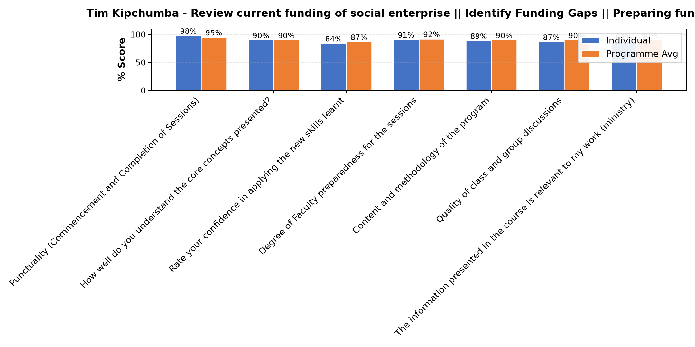

Comments & Feedback
- • Enough capital
- • Benefactors
- • The subject was good
- • A big problem is lacking money, which would help us in our plans which are not yet finished like fence administration and so on. But we are struggling to get some money.
- • What I learned was clear it is now on my side to put into implimantation
- • Resistance to change
- • Network
- • Good participation
- • Economic barriers
- • Lack of good connection with right donors to support our SE
SUBMITTED THROUGH:
SBS Evaluation Automation System

